Role Profile
 | Role title  Fundraising and Marketing Volunteer
 | Department  Fundraising and Marketing
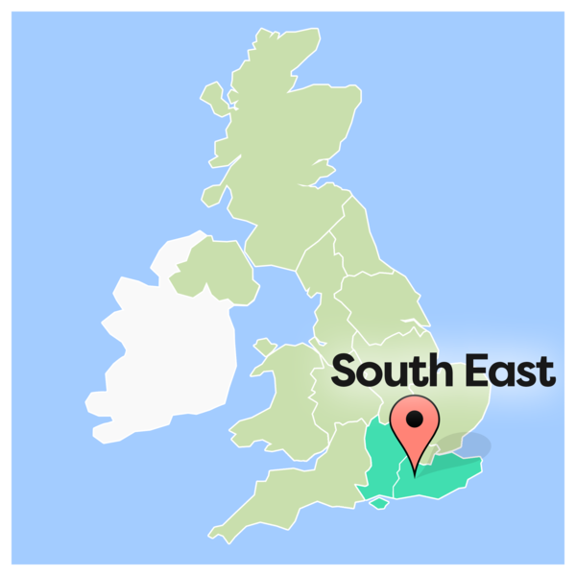 | Location  Brighton & Hove  West Sussex
 | Line Manager  Debbie Pellett, Fundraising Manager
 | DBS  Standard
 | Work Hours  Ad hoc
 | Summary of the role  Grace Eyre are looking for volunteers to help distribute flyers and posters to promote various different things.  This is a great opportunity for people to help spread the word around their local community.
Tasks
 | Taking posters and flyers to places in the local community, including:  - Shops  - Pubs and cafes  - Community centres  - Gyms and leisure centres

Goals of the role
 | To help raise awareness of Grace Eyre.  To help build a positive relationship with our local community.

Person Specification
Criteria |  | Essential | Desirable
 | Education  No qualifications needed
 | Skills and qualities  - Enthusiastic  - Reliable  - Able to follow instructions | 
 | Knowledge and experience  - Knowledge of the local area
 | Accessibility  This role is open to everyone

Organisational Commitment
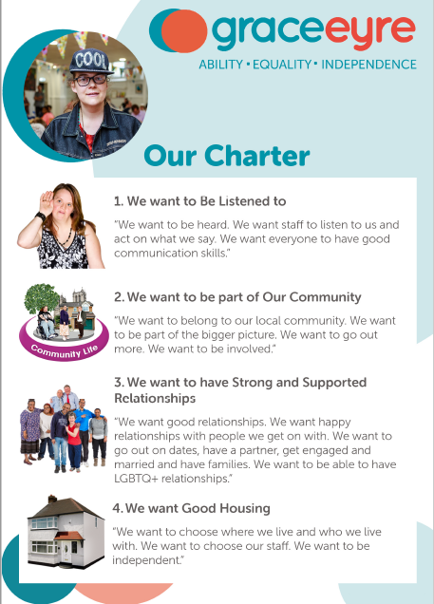 | Our Charter  - All people who join Grace Eyre commit to uphold and support achieving Our Vision, Mission and Our Charter
 | Equity, Diversity and Inclusion  - All people who join Grace Eyre commit to making sure our organisation is diverse, inclusive and accessible for all
 | Disability Confident Leader  - All people who join Grace Eyre commit to making sure that all jobs and roles are accessible for people with a disability

What you get in return
 | The chance to build confidence, self-esteem and make a difference
 | Be paid expenses
 | Training to support you grow and develop
 | Learn new skills/work experience/gain valuable charity experience
 | Be supported
 | Make good use of your current skills
 | Meet new people, be part of a team and make friends

