Role Profile
 | Role title  Flower Planter Maintenance Volunteer
 | Department  Fundraising
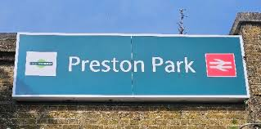 | Location  Preston Park Station
 | Line Manager  Debbie Pellett, Fundraising Manager
 | DBS  Standard
 | Work Hours  1 hour per week (flexible)
 | Summary of the role  Grace Eyre have partnered with Preston Park train station.  It is our job to look after the plant boxes on the platforms at the station.  We are looking for volunteers to help look after the plants and the boxes.
Tasks
 | - Weeding  - Watering  - Dead-heading and cutting back to encourage healthy growth  - Planting new plants  - Topping up soil  - Treating the wood of the planters

Goals of the role
 | To help make the station platforms look more welcoming.  To help raise awareness of Grace Eyre.  To help build a positive relationship with our local community.

Person Specification
Criteria |  | Essential | Desirable
 | Education  No qualifications needed
 | Skills and qualities  - Enthusiastic  - Reliable  - Able to follow instructions  - Interest in gardening | 
 | Knowledge and experience  - Knowledge of plants
 | Accessibility  The location of the planters on station platforms is not wheelchair accessible

Organisational Commitment
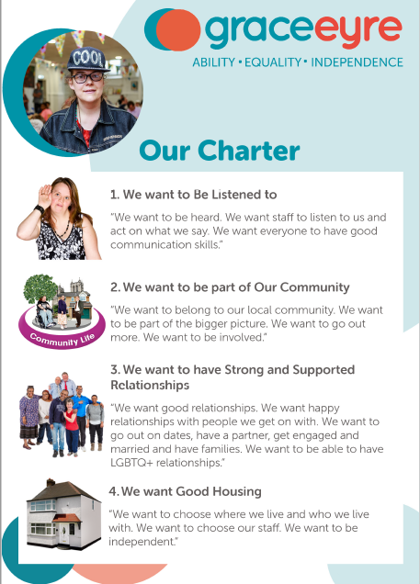 | Our Charter  - All people who join Grace Eyre commit to uphold and support achieving Our Vision, Mission and Our Charter
 | Equity, Diversity and Inclusion  - All people who join Grace Eyre commit to making sure our organisation is diverse, inclusive and accessible for all
 | Disability Confident Leader  - All people who join Grace Eyre commit to making sure that all jobs and roles are accessible for people with a disability

What you get in return
 | The chance to build confidence, self-esteem and make a difference
 | Be paid expenses
 | Training to support you grow and develop
 | Learn new skills/work experience/gain valuable charity experience
 | Be supported
 | Make good use of your current skills
 | Meet new people, be part of a team and make friends

