Application Form

Job name/Volunteer role:

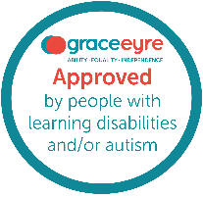
Your Personal Details

 | Name:
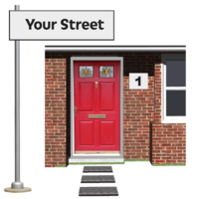 | Address:
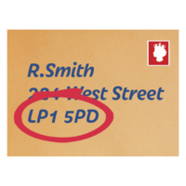 | Postcode:
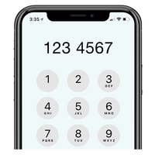 | Home phone number:  Mobile phone number:
 | Email address:
 | National Insurance number:
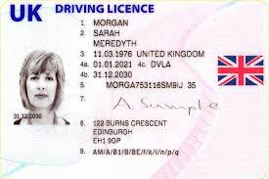 | Driving Licence: ☐ Yes ☐ No  If yes: ☐ Car or ☐ Motorbike  Do you have a D1 Category (where you can drive over a 7.5-tonne vehicle) on your Driving Licence?  ☐ Yes ☐ No
 | How did you hear about this job?
Work / Voluntary Experience:

 | What work/volunteering are you doing now?
Previous Jobs or Volunteering or other work:

Previous Job/Volunteering/Other Work:

Company Name:

Dates:

Previous Job/Volunteering/Other Work:

Company Name:

Dates:

Previous Job/Volunteering/Other Work:

Company Name:

Dates:

Your skills, experience and knowledge for the role

 | Why would you be good at this role?
 | What skills do you have (give examples)?
 | What is your previous experience (give examples)?
 | What knowledge do you have (please give examples)?
 | Anything else?
Your education, qualifications and training for the Role

 | What Education, Qualifications or certificates do you have (relevant to role)?
 | What training have you had (relevant to role)?
 | Anything else?
Work Availability (please tick)

 |  | Mon | Tues | Wed | Thurs | Fri
 | Morning
 | Afternoon
 | What is your notice period for where you work now?
Other Information
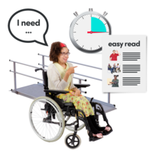 | Do you have a disability?* ☐ Yes ☐ No ☐ Prefer not to say  If yes, then tell us if there are any things we need to put in place for you to do a recruitment activity:  What type of recruitment activity would you like?  ☐ Online interview  ☐ In person interview  ☐ Interview with support staff or family member  ☐ Task or activity to complete  ☐ Trial Shift  Other things you might want:  ☐ Interview Questions in advance  ☐ Instructions for task or activity given in advance  ☐ Trial shift information given in advance  ☐ One-page profiles of team that will be recruiting you  Please note that if you have your skills and ability assessed by a task or trial shift, then you will still need to have an informal interview with the recruiting team.  *If you have a disability and meet all the essential minimum criteria on the job specification, we will offer you an interview. If you need support please let us know, by emailing: recruitment@grace-eyre.org
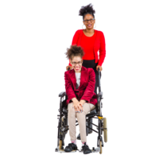 | Do you have a Support Worker? ☐ Yes ☐ No  If you are happy for us to contact them, please tell us their:  Name:  Address:  Telephone number:  Can we ask you Support Worker about your skills?  ☐ Yes ☐ No
Do you know anyone who works, volunteers or is a trustee at Grace Eyre?

☐ Yes ☐ No

If yes, what is their name and how do you know them?

Name:

How I know them:

In the last three years have you had any disciplinary action?

☐ Yes ☐ No

If ‘yes’, please tell us about this:

Do you have any criminal convictions or cautions?*

☐ Yes ☐ No

If ‘yes’, please tell us about this:

* This should include any spent convictions under Section 4 (2) of the Rehabilitation of Offenders Act 1974
Have you even been stopped from working with vulnerable adults?

☐ Yes ☐ No

If ‘yes’, please tell us about this:

Do you have the right to work in the United Kingdom?

☐ Yes ☐ No
Are you fully vaccinated against COVID-19?

☐ Yes ☐ No

Please note, we require all new staff to have had 2 vaccinations.

Are you happy to follow all Grace Eyre’s COVID Guidelines when at work?

☐ Yes ☐ No

References
 | Please give us the names, addresses and phone numbers of 2 people who can tell us about you. One of them must be your current or last employer, or if you haven’t been employed before, a personal, or college reference. We will contact them.
First Contact
 | Name:
 | Job Title:
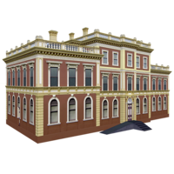 | Company:
 | Address:
 | Phone Number:
 | Email Address:
Second Contact
 | Name:
 | Job Title:
 | Company:
 | Address:
 | Phone Number:
 | Email Address:
Declaration
Please read the statement below and sign the form only if you agree with it.

- Everything I have written in this form is true.

- I understand that if anything I have written is not true, you won’t offer me the job/volunteer role.

- If you find out later that something I said is untrue, I won’t be offered the job/volunteer role or I may be dismissed.

Please sign here:

Date:

Please return to Grace Eyre by post, email or by hand:

Address: Grace Eyre, 36 Montefiore Road, Hove, BN3 6EP
Email: recruitment@grace-eyre.org

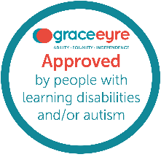
Equal Opportunities Monitoring Form

Grace Eyre is committed to promoting equal opportunities.

This means, that we make sure that everybody has the chance to take part in the activities and decisions that happen at Grace Eyre.
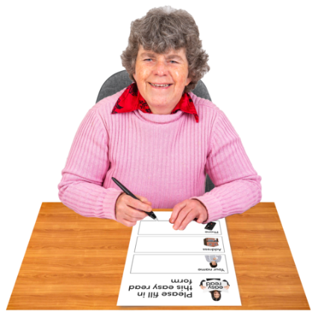 | By filling in this form, you will help us understand who we are reaching and how we can better support everyone in the community.
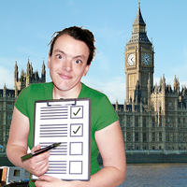 | By providing this information we will be able to check that we are meeting our commitments that have been laid out by the government.
 | You have the right not to tell us the information.
The information you give us will not be stored with any identifying information about you.

That means, your name will not be linked with this information.
 | All information is held in line with the Data Protection Act (2018).
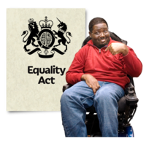 | The information that we need to collect is in the Equality Act (2010).  This information is: age, disability, gender reassignment, marital status, maternity, race, religious belief, sex and sexual orientation.
About you
Your role at Grace Eyre

Please tick the box that you consider to be your role at Grace Eyre:

☐ Member of staff
☐ Person we support
☐ Volunteer
☐ Shared Lives Carer
☐ Trustee
Ethnic Identity
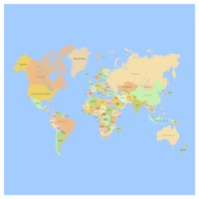 | Please tick which one applies to you:  Asian/Asian British  ☐ Indian  ☐ Pakistani  ☐ Bangladeshi  ☐ Chinese  ☐ Any other Asian background  Mixed/multiple ethnic groups  ☐ White and Black Caribbean  ☐ White and Black African  ☐ White and Asian  ☐ Any other mixed/multiple ethnic background  Black/African/Caribbean/Black British  ☐ Caribbean  ☐ African  ☐ Any other Black/African/Caribbean background  White  ☐ English  ☐ Northern Irish  ☐ Scottish  ☐ Welsh  ☐ British  ☐ Irish  ☐ Gypsy/Irish traveller  ☐ Any other White background  Other ethnic group  ☐ Arab  ☐ Any other ethnic group  ☐ Prefer not to say
Age
Please tick the box with your age:

☐ 18 - 24
☐ 25 - 34
☐ 35 - 44
☐ 45 - 54
☐ 55 - 64
☐ 65+
☐ Prefer not to say
Sex
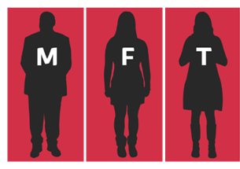 | Please tick the box that you consider to be your sex:  ☐ Male  ☐ Female  ☐ Transgender  ☐ Non-binary  ☐ Other  ☐ Prefer not to say
Gender re-assignment
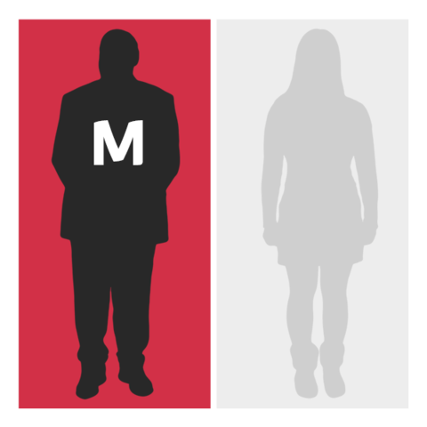  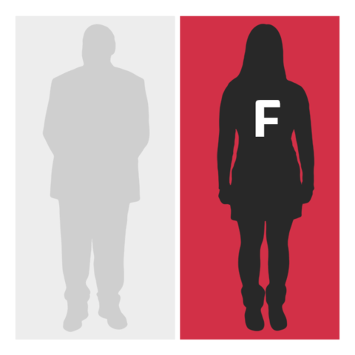 | Have you gone through any part of a process (including thoughts or actions) to change from the sex you were described as at birth, to the gender you identify with? Or do you want to do this in the future?  This could include:  - Changing your name  - Wearing different clothes that are like what the opposite sex wear  - Taking hormones  - Or having any gender reassignment surgery  ☐ Yes  ☐ No  ☐ Prefer not to say
Sexuality
Please tick the box that you consider to be your sexual orientation:

☐ Heterosexual/Straight
☐ Gay
☐ Lesbian
☐ Bisexual
☐ Pansexual
☐ Asexual
☐ Other
☐ Prefer not to say

Religion/belief
Please tick the box that applies to you:

☐ No religion
☐ Buddhist
☐ Christian
☐ Hindu
☐ Jewish
☐ Muslim
☐ Sikh
☐ Atheist
☐ Agnostic
☐ Other
☐ Prefer not to say

Disability
The Equality Act (2010) says a person is disabled if they have a physical or mental impairment which has a substantial and long-term effect on their ability to carry out normal day-to-day activities.
This includes conditions such as cancer, HIV, mental illness and learning disabilities

Do you have a disability?
☐ Yes
☐ No
☐ Prefer not to say

If you selected yes, please tick the type of disability:

☐ Vision (such as being blind or partially sighted)
☐ Hearing (such as being deaf or hard of hearing)
☐ Mobility (such as difficulty walking, climbing stairs or lifting)
☐ Learning Disability (such as needing support with independence or difficulty learning new skills)
☐ Learning Difficulty (such as dyslexia or dyscalculia)
☐ Mental health (such as depression or anxiety)
☐ Physical Health (such as COPD, stamina or breathing difficulties/asthma)
☐ Social or communication (such as Autism, OCD or ADHD)
☐ Other impairment (please state):
☐ Prefer not to say

Carer responsibility

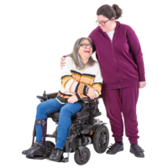 | Do you look after, or support family members, friends, neighbours or others because of:  · Long-term physical or mental ill-health/disability  · Problems related to old age  ☐ Yes  ☐ No  If yes, what responsibilities do you have?  ☐ Primary carer of a child/children (under 18)  ☐ Primary carer of disabled child/children  ☐ Primary carer of disabled adult (18 and over)  ☐ Secondary carer  ☐ Prefer not to say

