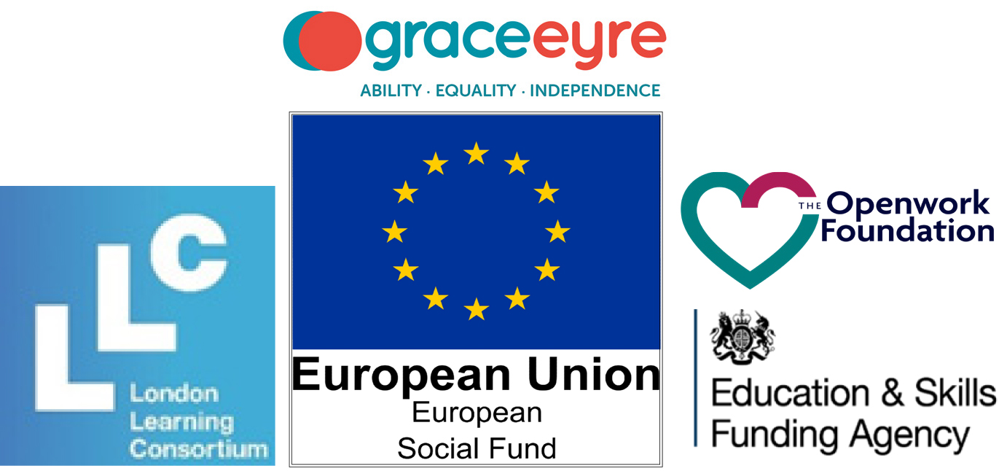

Lets Work Together
- Eligibility
The course is funded by the European Social Fund and will therefore be free for the learner. There is certain eligibility criteria and evidence the learner will need to evidence to be able to enrol onto the course.

Does the individual being referred have the following:
(Please tick and state which type of evidence will be provided)

National Insurance Number
(No formal document needed, just the correct number)
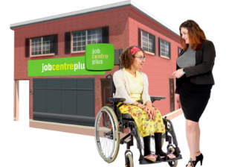 | Learners must be either unemployed or economically inactive (please specify), and provide evidence of benefits if claiming.  (Bank statement, DWP letter—must be dated within the last three months)
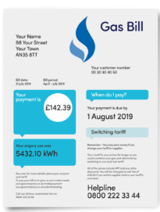 | Evidence of residency/address  (Driving licence not acceptable, instead: utility bill, bank statement, tenancy agreement, council tax bill—must be dated within the last three months)
Evidence of right to work in the UK.

(Passport, birth certificate, visa)

Learners must live within the following Boroughs to be eligible for funding:

Nonetheless, the training provided is aimed to be face to face and will require completing work experience placements within Brighton and Hove, so learners will need to be able to travel to and from Montefiore Road, Hove.

- Arun
- Adur
- Brighton & Hove
- Chichester
- Crawley
- Epsom and Ewell
- Horsham
- Mid Sussex
- Mole Valley
- Reigate and
- Banstead
- Tandridge
- Worthing
The funding from the ESF has been provided to specifically work with individuals who consider themselves as having a long-term disability, learning disability and / or autism, or learning difficulty.

Please give details of the support the individual will require during learning, and any reasonable adjustments we can make:

- Suitability of Training
The Let’s Work Together Project sets out to work with individuals for 11-month period, as part of this learners must commit to:
- Participating in at least 20 hours of work experience
- Engaging in at least 48 hours of employment training

Please detail any educational and / or personal barriers to completing the training programme, and what we can do to help overcome barriers
The funding from the ESF has been provided to specifically help individuals make meaningful steps towards employment, and therefore progression into paid employment, or further education is important.

What progression does the individual want to achieve from doing the course? Please tick
Paid Employment | Further Education |  | Other (please specify):

Please detail any specific areas of employment training that the individual would benefit from, for example, customer service skills, building a CV, job search skills, completing an application, attending an interview, etc…
Any additional comments:

- Personal details of individual you are referring / or your personal details if self-referring
 |  | Full Name
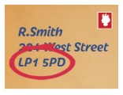 |  | Address
 |  | Phone number
 |  | Email address
Date of Birth

(Must be 18 + to enrol)
What is the best way to contact the referral? Please tick
Landline | Mobile |  | Email |  | 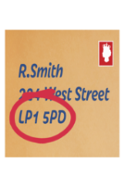  Letter

