One Page Profiles – for Trustees
What is a one page profile?
One page profiles are a quick way to get to know someone. They have the key information you might want… your name, picture, what people like best about you and what you are good at.
Originally one page profiles were used to get to know someone who may not be able to explain for themselves. It helps us get to know them quickly, and start conversations about things they like. Now they are used for lots of different reasons, by staff and the people we support.
Why do we want them?
As part of Grace Eyre recruitment the service user panel use one page profiles. They have the basic information we need to help with interviews.
These one page profiles are based on work. When filling them in only share information you are happy for everyone to read. Everyone at Grace Eyre has a one page profile to share key information.
How do I make a one page profile?
One page profiles can be as creative as you like. If you want to fill in the boxes with words that is fine, if you want to use pictures that is also fine! Please remember the interview panel is made up of people with learning disabilities. Keep the information short and to the point. We can discuss it in the interview if you want to give more information.
They can be made electronically or by hand.
Please see the information below to find out what to put in each part of the one page profile. They are live documents and can be changed as you need to. And are yours… it isn’t wrong if you are happy with it!
Any questions?
If you have any questions about completing the one page profile please contact our Kelly Palermo at kpalermo@grace-eyre.org or on 07584 431952

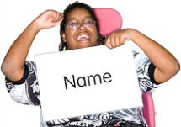My Name: Put your name here

Like and admire  Ask your friends and family, or colleagues, to say what they like and admire about you.  It must be positive!  Add things you like about yourself. It helps us get to know you. | Photo  Choose a photo which either  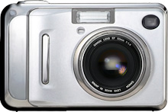  - Shows your face  - Shows you doing something you like  (no other people in it)

Things that are important to me:

This is about things that are really important to you. Not things you need to keep healthy, for example, but the things that really make you tick! Things that we can use to start a conversation with you.
You can keep it work focused if you like.

Examples:
- It is really important to me to arrive early to have time for a cup of tea!
- For people to tell me if I have done a good job.
- To say good morning and feel welcome.

How you can best support me:

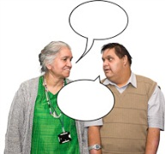
This is for things we can do to help sure the things that are really important to you can happen. It is to help us recognise that we all have strengths and weaknesses and helps us work as a team. It might be linked to the box above.

Remember this will be a public document, if you have specific support needs you can discuss them with your manager in private.

For example:
- Offer me tea if you are making one!
- Tell me when I have done a good job
- I work better when I have a deadline, if you give me work tell me when it needs to be done by.

